Certificate Of Authenticity
This certifies that this piece of art identified herein is a one-of-a-kind authentic, original produced by the artist ... This piece has been hand signed by the artist. All copyright and reproduction rights are fully retained by the artist. The artist can be contacted any time using the following email, or website:
…

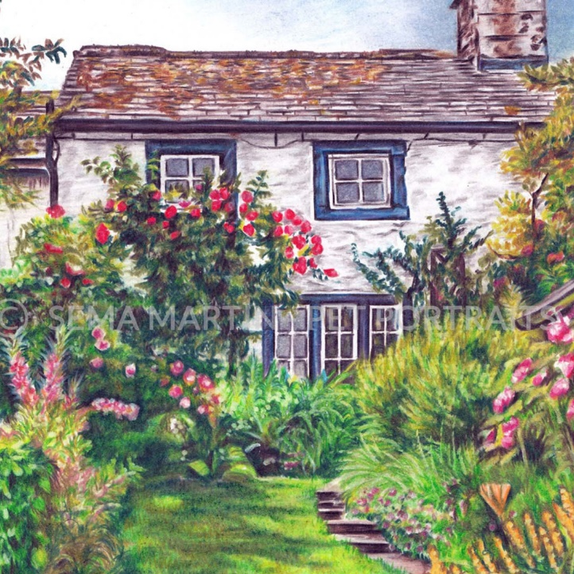
Title of Artwork:

Artist’s Name:

Dimensions:

Date Produced:

Medium & Materials:

Special Instructions:

Artist Signature Date Signed

